Attachment1 | <2026 Jongmyo Daeje> Overview

○ Date & Venue: Sunday, May 3, 2026, 10:00 a.m.–4:30 p.m. / Main Hall and Yeongnyeongjeon Hall, Jongmyo Shrine
○ Hosted by: Korea Heritage Service
○ Organized by: Korea Heritage Agency; Jongmyo Daeje Organizing Committee (Jongmyo Jerye Preservation Society; Jongmyo Jeryeak Preservation Society)
○ Main Contents: Performance of the Jongmyo ancestral rite; presentation of Jongmyo Jeryeak (royal ritual music) and Ilmu (dance)
○ Program Schedule
① Ancestral Rite at Yeongnyeongjeon Hall – 10:00 a.m.–12:00 p.m.
② Royal Procession (Eogahaengnyeol) – 11:00 a.m.–12:00 p.m.
* Route: Gwanghwamun Gate (Gyeongbokgung Palace) → Sejongno Intersection → Jongno 1, 2, and 3-ga → Jongmyo Shrine
③ Ancestral Rite at the Main Hall – 2:00 p.m.–4:30 p.m.
* Entry begins at 1:00 p.m. / Live broadcast via YouTube
④ Post-event – 4:30 p.m.–5:30 p.m.
Viewing of the Sinsil (spirit chambers): invited guests → general attendees

<Order of the royal ancestral rite>
Procedure | Ritual Act | Meaning | Music | Dance
Chwiwi | - | Placing of ancestral tablets
Jincheonghaengsa | - | Official request to Choheongwan to start the ceremony | Botaepyeongjiak  (Gungga) | Botaepyeongjimu (Munmu)
Singwanrye | Yeongsin | Greeting the spirits | Botaepyeongjiak  (Deunga) | Botaepyeongjimu (Munmu)
Gwesikrye | Jinchan | Presenting the spirits with food | Punganjiak  (Gungga) | -
Choheollye | Heonjak | First obeisance | Botaepyeongjiak (Deunga) | Botaepyeongjimu (Munmu)
Aheollye | Heonjak | Second obeisance | Jeongdaeeopjiak (Gungga) | Jeongdaeeopjimu (Mumu)
Jongheollye | Heonjak | Last obeisance | Jeongdaeeopjiak (Gungga) | Jeongdaeeopjimu (Mumu)
Eumbongnye | Sujak/Sujo | Partaking of sacrificial food | - | -
Cheolbyeondu | Cheolbyeondu | Overturing of ritual dishes | Ounganjiak (Deunga) | -
Songsinrye | Songsinsabae | Sending off the spirits | Heunganjiak  (Gungga) | -
Mangnyo | - | Incineration of prayers | - | -

○ Inquiries: Jongmyo Daeje Officer, Korea Heritage Agency Royal Palace and Tomb Project Department (☎ 02-3011-7742,7743)

Attachment2 | <2026 Jongmyo Daeje> Reference Photos

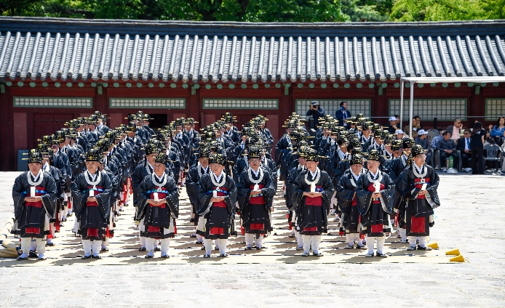 | 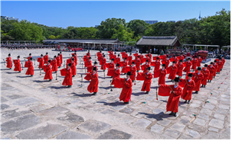
Main Ancestral Rite at the Main Hall of the 2025 Jongmyo Daeje
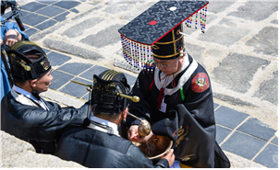 | 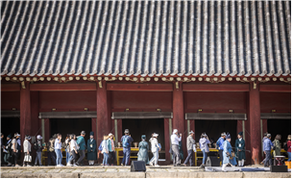
Main Hall Rite and Sinsil Viewing at the 2025 Jongmyo Daeje
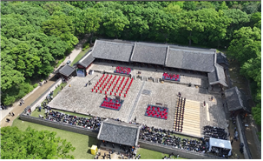 | 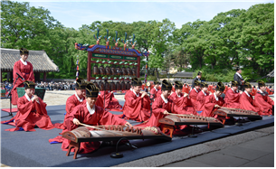
Ancestral Rite at Yeongnyeongjeon Hall during the 2025 Jongmyo Daeje

Attachment3 | <2026 Jongmyo Daeje> Promotional Material



