
NEWS RELEASE
Date: Friday, May 15, 2026
Contact:
Media Diversity Policy Division (02-2110-1460, 1293)

DOMESTIC PRODUCTION DEMAND STAGNATES AMID NETFLIX’S GROWING MARKET DOMINANCE
Findings from the “2025 Broadcasting Market Competition Assessment” Released: Downward Trend in Broadcast Advertising Revenue Persists

While overall demand for domestic video content production has stagnated, Netflix’s influence is on the rise.

Total broadcasting revenue has recorded negative growth for two consecutive years, with the decline in broadcast advertising revenue persisting.

The Korea Media and Communications Commission (KMCC; Chairperson Kim Jong-cheol) and the Korea Information Society Development Institute (KISDI; President Rhee Sang-kyu) announced on the 15th that the findings of the “2025 Broadcasting Market Competition Assessment” would be presented during the 10th Plenary Meeting of 2026 and reported to the National Assembly.

The assessment is conducted annually under the Broadcasting Act to promote efficient and fair competition. Taking into consideration substitutability on both demand and supply sides, the assessment delineates and analyzes four distinct markets: the pay broadcasting market, the broadcasting channel transaction market, the broadcast and video content transaction market, and the broadcasting advertising market.

The 2025 assessment utilized media market-related data, including the 2024 disclosure of broadcasting operators’ financial status, accounting reports, and reports on the state of the broadcasting industry. The assessment was also conducted based on last year’s surveys among users, production companies, advertisers, and other related stakeholders.

The key findings for each segment of the broadcasting market are as follows:

1. Pay Broadcasting Market
* A market where pay broadcasting operators, including Internet multimedia broadcasting operators (IPTV) and System Operators (SOs), provide pay broadcasting services and acquire subscribers.

The pay broadcasting market continued to experience stagnant growth in both subscriber numbers and revenue in 2024, following similar trends observed in 2023.

The total number of subscribers reached 36.3 million in 2024 (based on terminal subscriptions) while broadcasting business revenue totaled KRW 7.2361 trillion, representing year-on-year increases of only 0.04% and 0.1%, respectively. The findings suggest that the overall growth momentum of the pay broadcasting market is weakening due to intensifying competitive pressure from over-the-top (OTT) services, among other factors.

Within the pay broadcasting market, affiliates of the three major Internet multimedia broadcasting operators (IPTV) accounted for 87.2% of subscribers and 91.7% of revenue in 2024. The findings indicate that market concentration in the pay broadcasting sector continues to increase.

According to the report, however, the increasing concentration of the pay broadcasting market is unlikely to lead to higher subscription fees as competitive pressure from OTT services on pay broadcasting providers continues to intensify.
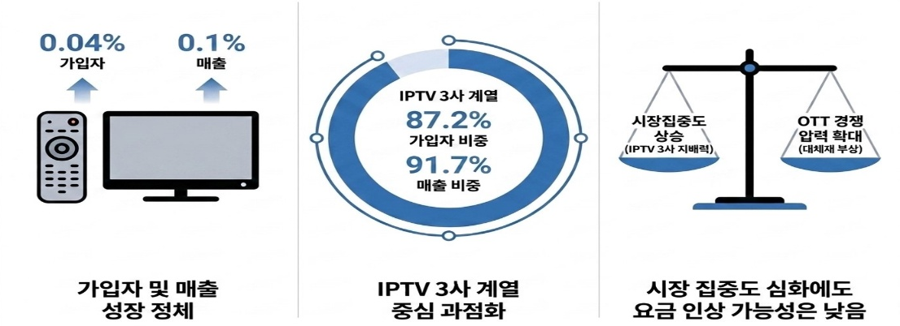
Intensifying Competitive Pressure from OTT Services
(Rise of Substitute Services)
Increase in
Market Concentration
(Dominance of the Three Major IPTV Operators)
Despite Increased Market Concentration,
the Likelihood of Price Increases Remains Low
Oligopolistic Market Structure Centered on
the Three Major IPTV Operators
Stagnation in
Subscriber and Revenue Growth
Affiliates of the Three
Major IPTV Operators

Subscriber Share
87.2%
Revenue Share
91.7%
0.1%
Revenue
0.04%
Subscriber

2. Broadcasting Channel Transaction Market
* A market where broadcasting channel transmission rights are traded between pay broadcasting operators and program providers (PPs).

Total broadcasting channel provision revenue reached KRW 1.5629 trillion in 2024, marking a 4.6% year-on-year increase and indicating continued market growth.

With the market shares of major pay broadcasting operators continuing to rise, they are likely to wield significant bargaining power over PPs based on their channel programming authority.

Competition for content between pay broadcasting operators and OTT platforms has intensified, meaning that program providers with popular channels are also deemed to possess considerable bargaining power.

Meanwhile, home shopping transmission fees continued to increase but at a significantly slower pace, rising only 0.2% year-on-year in 2024 as home shopping broadcasting revenue has declined since 2022.

The report forecasts that disputes over broadcasting channel fees and home shopping broadcasting revenue commissions between buyers (pay broadcasting operators) and suppliers (PPs) in the broadcasting channel transaction market could increase further should downturns in both the broadcasting advertising market and the pay broadcasting market deepen.
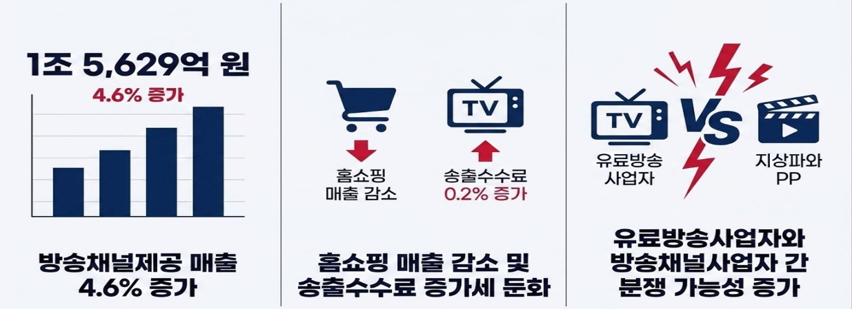
Terrestrial Broadcasters & PPs
Pay Broadcasting Operators
2.2% Increase in Transmission Fees
Home Shopping Sales Decline
Increased Potential
for Disputes Between
Pay Broadcasting Operators and PPs
Declining Home Shopping Sales &
Slowing Transmission Fee Growth
4.6% Increase
in Channel Revenue
4.6% Increase
KRW 1.5629 Trillion

3. Broadcast and Video Content Transaction Market
* A market where broadcasting or transmission rights for broadcast and video content are traded among PPs, OTT service providers, and production companies.

The “broadcast and video content transaction market” was found to show overall stagnation in domestic production demand amid the continued expansion of Netflix’s influence.

Direct production expenditures by broadcasters, including in-house production, outsourced production, and content purchases, increased 2.3% year-on-year to KRW 2.9709 trillion in 2024. However, outsourced production expenditures declined 2.2% year-on-year to KRW 987.8 billion.

The total number of drama titles supplied by broadcasters and OTT service providers in 2024 stood at 108, down slightly from 112 in the previous year. While production demand from domestic operators declined, demand from global OTT platforms increased.

Netflix maintained a high level of Korean original content supply in 2024 with 30 titles, unchanged from 2023. Korean content also accounted for 8.8% of total global viewing hours on Netflix in 2024, ranking second only to US content. As a result, strong demand from Netflix for Korean content is expected to continue for the foreseeable future.
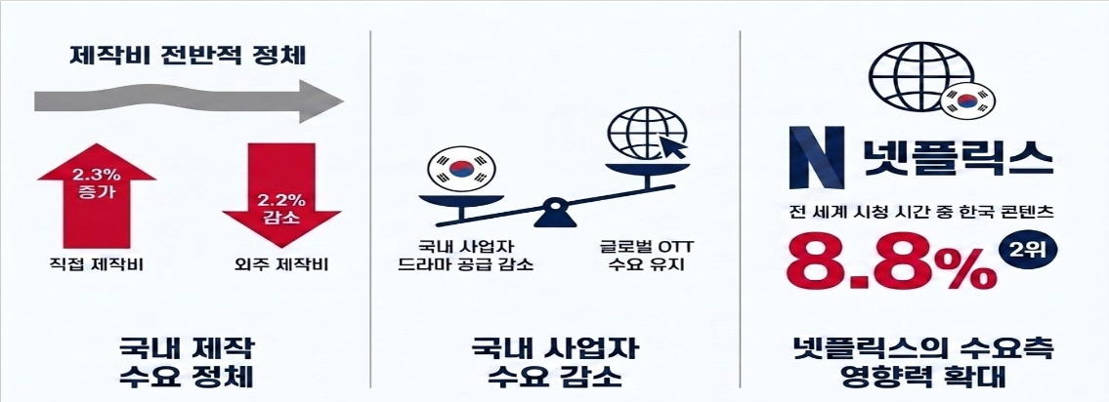
Continued Demand from Global OTT Platforms
Decline in Drama Supply by Domestic Operators
Share of Korean Content in Global Viewing Hours
Stagnation in
Domestic Production Demand
Outsourced Production Expenditures
Overall Stagnation in Production Demand
No. 2
Netflix
2.2% Decline
2.3% Increase
Direct Production Expenditures
Declining Demand
from Domestic Operators
Growing Influence of Netflix
on Market Demand

4. Broadcasting Advertising Market
* A market where broadcasting operators, including PPs and pay broadcasting operators generate advertising revenue by selling TV advertising airtime to advertisers.

The “broadcasting advertising market” declined 6.8% year-on-year to KRW 2.1976 trillion. The share of TV broadcasting advertising in the overall advertising market, excluding radio, also fell 1.5 percentage points year-on-year to 17.7%, continuing its downward trend.

The share of broadcasting advertising within the total advertising market is rapidly decreasing as viewing platforms diversify and online advertising continues to grow. Subscriber growth for ad-supported plans offered by OTT platforms such as Netflix and TVING is also accelerating, and this is expected to further increase substitution pressure on traditional broadcasting advertising.
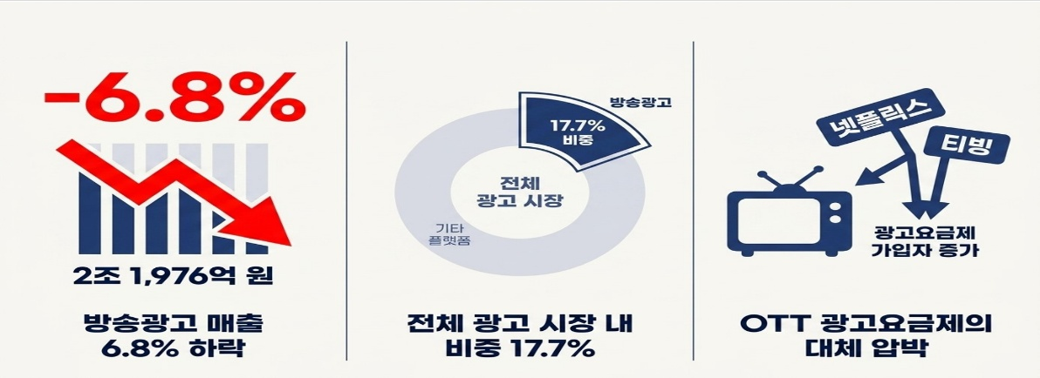
Overall
Advertising Market
Broadcast Advertising
17.7%
Market Share
17.7% Share of
the Total Advertising Market
Broadcast Advertising Revenue
Down 6.8%
Other Platforms
TVING
Netflix
Increase in
Subscribers to
Ad-Supported Plans
KRW 2.1976 Trillion
Substitution Pressure from
OTT Ad-Supported Plans

As competition between traditional broadcasters and OTT service providers intensifies across the broadcasting market, the need for analysis encompassing OTT operators is becoming increasingly important. The report also cited the urgent need for institutional improvements aimed at securing relevant statistical data.

According to KMCC, the full “2025 Broadcasting Market Competition Assessment” report, along with key data and graphic files, will be made publicly available through the KMCC website (www.kmcc.go.kr) and the Media Statistics Portal (mediastat.or.kr).

###
The Korea Media and Communications Commission

