 | PRESS RELEASE

FOR IMMEDIATE RELEASE
Date of Release: 12 June 2026

FOR MORE INFORMATION
Seung-ho Choi, Foreign Press Spokesperson
TEL: 82-44-201-1120
E-mail: csh9731@korea.kr

From Joseon Palaces to Modern Homes: New Exhibition Unveils the Rich History of Korean Floral Art

Sejong, 12 June 2026 — The Ministry of Agriculture, Food and Rural Affairs (MAFRA) and the National Agricultural Museum (NAMUK) are currently presenting a special exhibition titled “Flowers Blooming at Our Fingertips,” which opened on 9 June and will run until 5 October at the Museum.
The exhibition showcases floriculture-related artefacts that the Museum has carefully collected and preserved over the years. Through 115 exhibits, including books, ceramics, and paintings, visitors will have the opportunity to explore the cultural significance of flowers and the historical importance of Korea’s floriculture industry.
The exhibition is organised into three sections, tracing the history of flower cultivation and use in chronological order. The first section, titled “Close at Hand,” introduces the garden culture of Korean ancestors alongside records of floral management in royal palaces during the Joseon Dynasty. A key highlight of this section is Yanghwa Sorok (On Planting Flowers)—Korea’s earliest professional treatise on floriculture, written by the 15th-century scholar Kang Hui-an and preserved within the family anthology Jinsansego. Other key highlights include the Gyeonggukdaejeon (the State Code of the Joseon Dynasty) and Goeseok Hwajeop (Painting of Fantastically Shaped Rocks, Flowers, and Butterflies).
The second section, titled “Blooming Within the Garden Walls,” examines the symbolism and uses of flowers in everyday living spaces. The display features a magnificent an eight-panel folding screen of Chaekgado (Scholar’s Accoutrements). This masterpiece vividly illustrates how books, precious antiquities, and seasonal flowers in vases were harmoniously integrated into the domestic spaces of Joseon scholars, reflecting their deep-seated scholarly aspirations and refined lifestyle.

Other key highlights are as follows: (a) Cheongja Sanggam Donghwa Gukhwamun Hap (Celadon Lidded Box with Inlaid and Underglaze Copper-Red Chrysanthemum Design), a rare masterpiece demonstrating the zenith of Goryeo celadon technology, featuring a sophisticated combination of slip-inlay and risky copper-red underglaze techniques; (b) Chanhap (Multi-Tiered Food Box), used by Joseon ancestors for outdoor excursions to enjoy seasonal blossoms, merging culinary art with the appreciation of nature; and (c) Dongui Bogam (Principles and Practice of Eastern Medicine, inscribed on the UNESCO Memory of the World Register), highlighting the scientific and medicinal value of flowers as active ingredients in traditional Korean healthcare.
The third section, titled “Blooming at Our Fingertips,” explores how floral culture became widely embraced, developing into a lifestyle and cultural industry. A particularly captivating highlight of this section is Indu Hwajodo (Ten-Panel Folding Screen of Flowers and Birds Drawn with Hot Iron). This rare masterpiece showcases the extraordinary Korean tradition of nakwha (pyrography), where master artisans eschewed traditional brushes and ink, using precisely heated irons instead to scorch breathtakingly delicate details of nature onto the screen, reflecting a profound harmony between fire, wood, and art.
While some exhibits display upper-class luxury, works like Jeonga Pungmi (The Rustic Charms of a Rural Homestead) celebrate the humble yet vibrant lifestyle of ordinary people. This piece beautifully illustrates the idyllic delights of the Korean countryside, showcasing how seasonal flora was naturally woven into the fabric of farming life, bringing poetic grace to the most modest of homes. Another key documentary highlight in this section is the Journal of the Floriculture Association. This historic publication vividly charts the modern evolution of the sector, illustrating the exact moment when Korean flower cultivation transitioned from a traditional leisure pursuit into a highly organised, professional industry.
The exhibition will run until 5 October and is open free of charge from 9.00 a.m. to 6.00 p.m., excluding Mondays. Further information is available on the National Agricultural Museum website (www.namuk.or.kr).

<Major Exhibits>
Section 1: Close at Hand
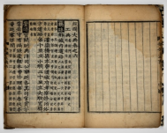 |  | 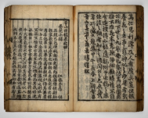 |  | 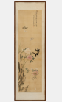
The Gyeonggukdaejeon (the State Code of the Joseon Dynasty) |  | Jinsansego (The Collected Works of the Jinsan Kang Family) - Yanghwa Sorok (A Treatise on Flower Cultivation |  | Goeseok Hwajeop (Painting of Fantastically Shaped Rocks, Flowers, and Butterflies).
Section 2: Blooming Within the Garden Walls
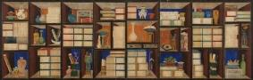 | 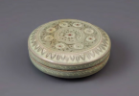 |  | 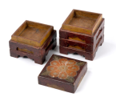 |  | 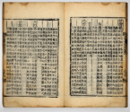
Chaekgado (Eight-Panel Screen of Books and Scholar's Possessions) | Cheongja Sanggam Donghwa Gukhwamun Hap (Celadon Lidded Box with Inlaid and Underglaze Copper-Red Chrysanthemum Design) |  | Chanhap (Multi-Tiered Food Box) |  | Dongui Bogam (Principles and Practice of Eastern Medicine, inscribed on the UNESCO Memory of the World Register)
Section 3: Blooming at Our Fingertips
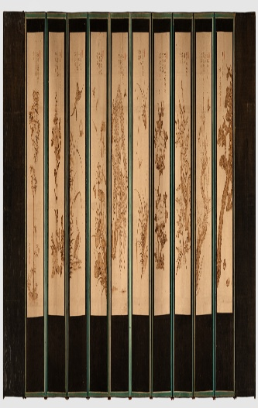 | 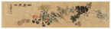 |  | 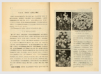 |  | 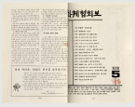
Indu Hwajodo (Ten-Panel Folding Screen of Flowers and Birds Drawn with Hot Iron) | Jeonga Pungmi (The Rustic Charms of a Rural Homestead) |  | Floriculture publication |  | The Journal of the Floriculture Association

